SPRING -2024

M8: Uncovering North American Causes of Death Trends

|  |
| --- |
| **Table of contents** |
| Abstract...........................................................................................3 |
| Introduction/Motivation..................................................................3 |
| Data Set...........................................................................................4 |
| Analysis...........................................................................................4 |
| Results.............................................................................................5 |
| Limitation of the study & Conclusion............................................12 |
| References……………………………………………………………….12 |

**Abstract**

For our North American (NA) Cause of Death study, which compared NA to other countries and regions, analyses were conducted to gain insight into data regarding annual deaths and its causes around the world along with current trends. Through analysis, there were several interesting findings that raise alarms about the severity of some of these instances. We found that in areas such as death by self-harm, it is slowly but steadily increasing yearly along with total deaths in NA. North America, specifically the United States, was found to be using more drugs than in past years and consequently increasing the death count on drug related deaths. An analysis of leading causes of death in North America from 1990-2019 found cardiovascular disease and cancer as the top killers, with differing trends for other diseases between the US, Canada, and Mexico over time. The dataset contains information on various causes of death such as cardiovascular diseases, infectious diseases, injuries, and more. Our findings below may help identify areas where public health interventions and policies could be targeted to improve overall population health.

**Introduction/Motivation**

Understanding leading causes of mortality is crucial for improving population health and longevity worldwide. However, trends can vary greatly by region and income level. This report focuses specifically on visualizing patterns in causes of death across North America over recent decades.

As a high-income region, North America has the resources to tackle issues like preventable communicable diseases. Yet troubling trends like rising substance abuse and suicide demonstrate new health challenges. By analyzing the available mortality data, we can identify priorities and allocate resources strategically to save lives.

Visualizing cause-specific death rates by geography, age, gender and time period will pinpoint populations experiencing the greatest risks. For example, are drug overdoses disproportionately impacting certain demographics? Are some countries seeing higher rates of death from preventable causes? The answers can guide targeted interventions.

This analysis aims to uncover insights that officials can use to set realistic public health goals. Where should funding be directed to drive down preventable deaths most effectively in North America in the coming years? How do trends in the region compare to global patterns? By exploring the mortality data visually, we can educate, inform policy, and inspire action towards the shared goal of improving quality of life.

**Dataset**

To analyze these questions, our team used the Cause of Death dataset collected by Our World in Data that contained data of several causes of death over time. They collected the data to help make informed decisions regarding public health. The data contained information from 1990-2019. However, the dataset itself was downloaded from Kaggle.com as a zip file. The data needed cleansing and preparation, so the team adjusted. This contained the total number of deaths by cause per country or area of the world.

Using the data, we focused on the 30 years of reporting and looked for trends to identify drastic changes in rates. The data was downloaded as a zip file that contained two excel sheets, one cleansed and one not. We used the cleansed file but still had to make our own modifications to prepare the data so that it was usable for all our goals in the study. In Tableau, the team used pivots, splits, filtering null values, and calculated fields to achieve the desired form. We also had to make additional adjustments in Excel. This was to make it easier to just load the updated excel file rather than do it in Tableau again.

**Analysis**

To analyze the data, the team utilized several visualization techniques to draw conclusions on the available data. To do this, we looked at time series data to gain an understanding of the trends that have developed globally. Using various graphs, we first wanted to compare global trends with North America and then delve deeper into the continent to find trends. As we unraveled trends, more questions arose that needed critical thought processes to solve. Line charts were a strong visual for us to easily see trends and be able to decide whether the information was pertinent. For analysis on leading causes of death in North America from 1990-2019, we cleaned and wrangled the causes of death data into a consistent format for the US, Canada, and Mexico from 1990 to 2019 by filtering, handling missing data, and normalizing column names. We then conducted exploratory analysis through visualizations like bar charts and mortality rate change calculations to understand overall trends and identify diverging patterns between countries. Finally, we compared cause of death rankings, changes over time, and optimized plots to effectively summarize key aspects of the data. For the analysis on World Death rate, analysis between road injuries and self-harm, and analysis of the rising rate of neoplasms (cancer), a line chart was used to show the data. A line chart makes it easy to see the change over time. This allows the reader to make their own judgements about the data.

**Results**

**Drug Use Disorder Deaths in NA 1990-2019**

With this visualization we see that North America has been skyrocketing in terms of growth with drug use related deaths since the 90s. The data dates to 1990, in which 6,306 deaths were reported for that year. For the next few years, the total steadily increased but at a rate that is not indicative of widespread harm, the numbers seemingly keep up with time and the growing population. As of 2019, the total has towered up to 68,243. That is an increase of ten times but the population hasn’t increased by ten times. However, by the year 2000, the total had already tripled. There are several possibilities for this. One reason is that Purdue released Oxycontin in 1996, which we now know to be addictive and very harmful. This drug was used and prescribed for many years before anything was done about it. The drug was even prescribed to teenagers and children.

The likely cause of the increased drug usage is because of the ongoing mental health crisis that has turned into a public health crisis. According to associate professor of health and kinesiology, Laura Schwab Reese (2018), “For every additional 1 percent of the population that has a depression diagnosis, we see between a 25 and 35 percent increase in the number of opioid overdose deaths”. This enlarges the clear link between mental health issues, such as depression, and drug use.

**North American Leading causes of death**

An analysis of leading causes of death in North America from 1990-2019 reveals cardiovascular disease and neoplasms (cancer) as the top two killers in the United States, Canada, and Mexico

Visualizing the data for these three countries with a stacked bar chart shows cardiovascular disease contributing to the most deaths each year, followed by cancer. The proportions remain consistent over time.

However, the 3rd through 5th ranked causes of death vary between the countries. In the US and Canada, chronic respiratory diseases, digestive diseases, and dementia round out the top 5 after heart disease and cancer. In contrast, Mexico sees higher mortality burdens from diabetes mellitus and chronic kidney disease in those rankings instead of dementia and digestive diseases.

**Heart disease remains the number 1 killer; diabetes and dementia enter the in top 5**

Heart disease remains the leading cause of death in the United States, across genders and racial groups. Over 695,000 Americans died from heart disease in 2021, accounting for 1 in 5 deaths. Coronary artery disease is the most prevalent type of heart disease, causing 375,000 deaths in 2021. About 2 in 10 coronary artery disease deaths occur in adults under 65.

Every 40 seconds, someone in the US has a heart attack. Heart disease costs the US about $240 billion yearly from healthcare services, medications, and lost productivity.

An analysis of year-over-year percentage change in mortality rates for leading diseases reveals differing trends between the United States, Mexico, and Canada from 1990-2019.

Neoplasms, chronic respiratory diseases, digestive diseases, dementia, and chronic kidney diseases show consistent annual increases in all three North American countries. However, cardiovascular disease and diabetes mellitus saw declines in the US and Canada specifically from 2000-2010 before reversing to steady annual increases after 2010.Meanwhile in Mexico, cardiovascular disease, and diabetes deaths increased year-over-year throughout the full time.

Visualizing the annual percentage change highlights these diverging patterns between the countries. While causes like cancer and respiratory illness increased everywhere, the data shows the US and Canada experienced brief improvements in cardiovascular and diabetes mortality in the early 2000s unlike Mexico. This reversal back to rising deaths in recent years suggests a need to re-examine policies and programs targeting heart disease and diabetes in the US and Canada.

Dementia is not a specific disease but rather a general term for the impaired ability to remember, think, or make decisions that interfere with doing everyday activities. It now ranks among the top 10 leading causes of death worldwide, including Alzheimer's disease. It ranks 3rd in the Americas and Europe. Hispanic and African Americans will see the largest increases in Alzheimer's disease between 2015-2060. Alzheimer's is the most common form of dementia, already impacting around 5.8 million Americans aged 65+ and 200,000 under 65. Women disproportionately represent 65% of dementia deaths globally.

Lower respiratory infections like pneumonia ranked as the 4th highest cause of death in 2019. Yet compared to 2000, deaths decreased by almost 500,000, representing major progress in communicable disease mortality.

**Death Rates in North America Compared to Births**

The total number of deaths in North America is increasing slowly. The graph above shows the death rate in North America as a whole and the three Countries that make up North America between 1990 and 2019. The graph remains steady but is increasing slightly. The United States is the country in North America with the Largest population. The United States also has the highest rate of death in North America as well.

Is the Death rate in the United State proportional to the birth rate? *US Birth Certificates.com* says otherwise. According to their website the death rate in the United States was increasing even before the Coronavirus pandemic (USbirthcertificates Team, 2022). The birth rate has been steadily decreasing since the early 2000’s. The website offers a few reasons for this decline. The website states that the decrease in births in the United States is because more citizens are deciding not to have children due to expenses (USbirthcertificates Team, 2022). Citizens that do decide to have children do not have as many children as previous generations. Another reason for the decline mentioned by the website is the lack of free healthcare. Expectant parents must pay the costs or have insurance to give birth with medical assistance (USbirthcertificates Team, 2022).

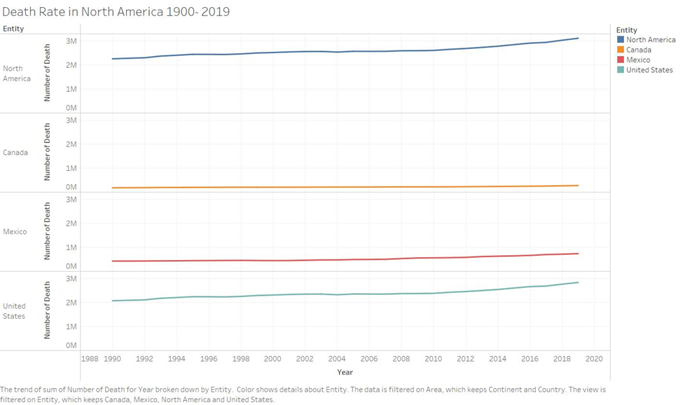

**Self-Harm Deaths and Suicides in North America**

Mental health has been a focus in recent years especially in North America and the United States. Suicide has become an epidemic in teenagers and young adults. Accounting to our dataset Self Harm Deaths and Suicides rank approximately Halfway (16th) down the list of causes of death in the World. In North America Self – Harm Deaths are number 11 in causes of death right behind “road injuries''. In Europe Self Harm Deaths are ranked number 8, above the “road injuries” category.

The line chart below shows the correlation between Self Harm Deaths and Suicides in both Europe and North America (Shown in Green). As you can see Europe shows a steady decline in deaths starting in the mid to late 1990’s. North America’s line is not as drastic but is increasing slightly from the mid to late 1990’s until 2019. The yellow lines show the deaths because of road injuries. This shows that more people are dying every year, after 1991, in Europe because of self-harm than road injuries. In North America the number of self– harm deaths passed road injuries deaths in 2009.

This shows that North America has entered a mental health crisis. An Article in the *National Library of Medicine* attempts to explain the increase in self-harm deaths. The article states that the increase in depression, anxiety, loneliness, and self - harm in adolescents and young adults began to rise around 2010, this correlates with the line for North America which begins to have a noticeable increase in its slope and pass road injuries in 2009. These behaviors lead to suicidal ideation, suicide attempts and suicide (Twenge, 2020). The article compares the trends to the rising use of technology and technology use among adolescents and young adults. The conclusion that the article came to is that there is a correlation between increased technology use and self – harm and suicide (Twenge, 2020). The article explains that the increase in smartphone usage and digital media influences mental health (Twenge, 2020). Increase in smartphone use means a decrease in time spent in in-person social interactions. That combined with the introduction of cyberbullying and toxic online environments may account for this spike in self – harm deaths (Twenge, 2020)

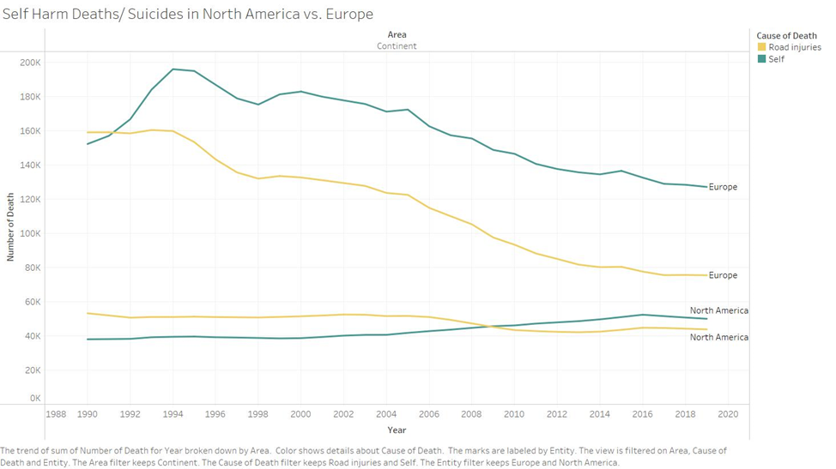

**Neoplasm Deaths Worldwide**

Neoplasms are the second leading cause of death worldwide. The only category that beats Neoplasms is cardiovascular disease. Neoplasm is an abnormal growth of cells in the body (Mirabito, 2023). The growth can be either non-cancerous or cancerous. Most of the time neoplasms are not dangerous to a person’s health, however if they are cancerous then they can lead to death (Mirabito, 2023). The graph below shows the trends of Neoplasms by continent. All the continents show an increase in Neoplasm deaths between 1990 and 2019. Asia shows the largest increase.

An article posted on the National Library of Medicine attempts to explain the increase in Cancer worldwide. The World Health Organization conducted a study and found no correlation between cancer deaths and countries income status (ReFaey, 2021). This means that cancer is affecting every country equally and the more money and resources a country has, does not influence cancer deaths. The article goes on to say that if the mortality rate of cancer continues its current path it is expected to surpass the mortality rate of cardiovascular disease and become the number one cause of death worldwide (ReFaey, 2021).

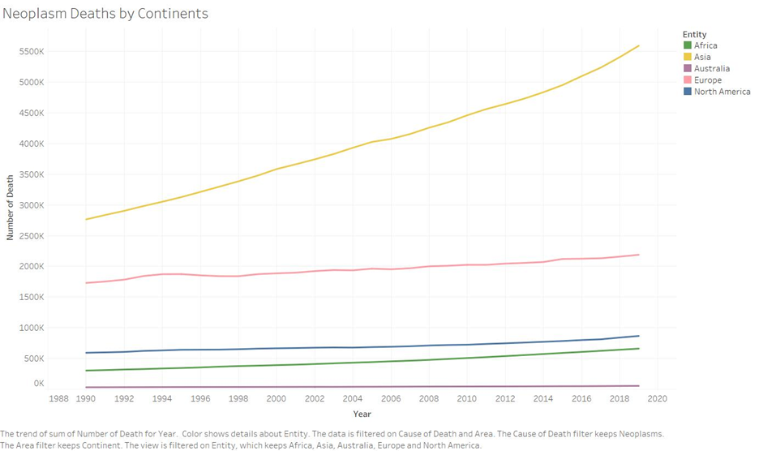

**Funding to Decrease Mortality rate in Current Causes**

The two leading causes of death in North America are cardiovascular disease and Neoplasms (Cancer). Both causes of death fall within the medical field and are related to a person’s health. As of now there is no universal cure for either disease. There are, however, things that can be done to prolong someone's life who has one of these diseases. Genetics plays an important role as to who is more susceptible to disease, but an individual’s lifestyle choices have also been linked to playing a part in the disease progression (ReFaey, 2021). According to an article published in the National Library of Medicine, cardiovascular disease may be overtaken by Neoplasms (Cancer) in the future. The article states that through advances in medical science and early detection methods less people are dying from cardiovascular disease (ReFaey, 2021). Neoplasms (Cancer) if detected early, can increase a person’s chances of survival or longer living (Mirabito, 2023). Putting funding towards early detection programs will allow more people to be diagnosed earlier which will allow them to manage their disease longer and in turn, live longer. Being able to slow the mortality rate of the world's two leading causes of death through early detection programs will decrease the world's death rate.

**Limitations of Study and Conclusion**

The dataset did a good job with what it was supposed to do, which was to provide numbers on worldwide deaths. However, the data was severely lacking in other aspects that could have greatly enhanced the ability to conduct analysis and come to a wide range of conclusions. The data did not contain information such as age, gender, or region. These variables would've been extremely useful for such a broad analysis. Other limitations include the lack of reliability of reporting. We will never get close to the true number of these causes because of lack of reporting, or its fraudulent use. These clear limitations prevent us from interpreting the wide range of results fairly. If the other factors had been a part of the dataset, our trends may have had different explanations than believed.

In conclusion, the dataset serves as a resource for us to uncover truths about our world and societies. This in turn helps us make informed decisions that are realistic and attainable. Even though there were limitations, we were able to make educated inferences about the world around us and how it has changed for better or worse. With the staggering rise of drug and suicide related deaths in North America, policy at the government level can be directed towards areas that need it most.

**References**

Hannah Ritchie and Edouard Mathieu (2023) - “How many people die and how many are born each year?” Published online at OurWorldInData.org. Retrieved from: 'https://ourworldindata.org/births-and-deaths' [Online Resource]

Kayla Zacharias and Laura Schwab Reese (2018) “Opioid overdoses, depression linked” Published online at purdue.edu. Retrieved from:<https://www.purdue.edu/newsroom/releases/2018/Q4/opioid-overdoses,-depression-linked.html>[Online Resource]

National Center for Health Statistics. [Multiple Cause of Death 2018–2021 on CDC WONDER Database](https://wonder.cdc.gov/mcd.html). Accessed February 2, 2023.

National Center for Health Statistics. [Percentage of coronary heart disease for adults aged 18 and over, United States, 2019—2021](https://wwwn.cdc.gov/NHISDataQueryTool/SHS_adult/index.html). National Health Interview Survey. Accessed February 17, 2023.

Agency for Healthcare Research and Quality. [Medical Expenditure Panel Survey (MEPS): household component summary tables: medical conditions, United States](https://meps.ahrq.gov/mepsweb/data_stats/download_data_files.jsp). Accessed April 8, 2021.

Alzheimer’s Association, 2019 Alzheimer’s Disease Facts and Figures, https://www.alz.org/media/Documents/alzheimers-facts-and-figures-2019